 Arlington Hills Community Center

1200 Payne Ave. Saint Paul MN, 55130 651-632-3861

EASTSIDE YOUTH DAY

SATURDAY SEPTEMBER 22, 2018

1pm-4pm

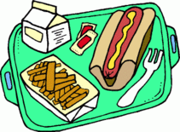  

Free youth and community event

Free food, games, talent showcase and FUN!

Vendors participants are welcomed.

Please contact Lenora at 612.702.4805 for more details or contact Ann at AHCC [ann.simerson@ci.stpaul.mn.us](mailto:ann.simerson@ci.stpaul.mn.us)

  