6th Annual Unify University! Community Parade
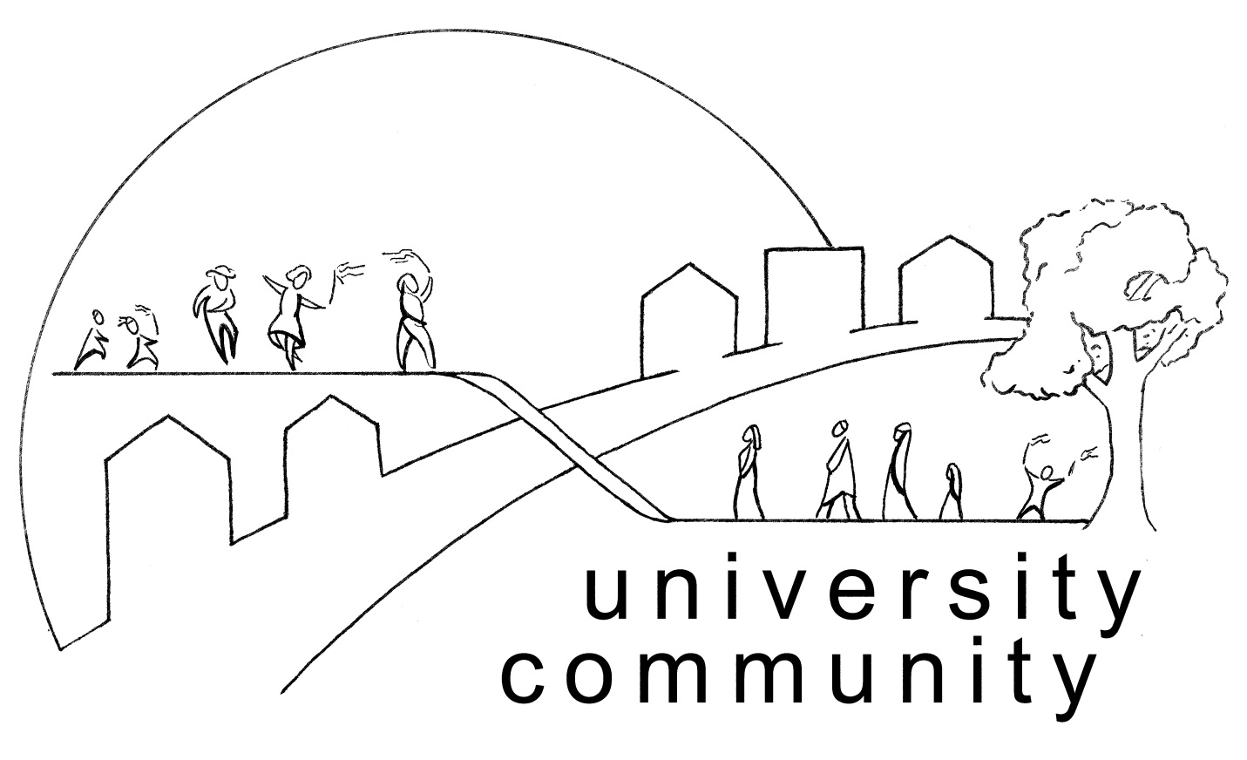

- Lineup at 4 PM Central Ave east of Victoria
- Circle at 4 45 PM, start at 5 PM, end at 6 PM
- End at Little Mekong Night Market – food, music, crafts, and art – until 12 Mid!

Saturday August 8th 5 PM – 6 PM
Name_______________________________________
Organization__________________________________
Address_____________________________________
Email_____________________ Phone___________________
Community Group Fee (budgets under $1 million) $30
Large Group Fee (budgets over $1 million) $60
Political Candidates fee $60
More info? unifyuniversity@gmail.com

Parade Newspaper
100 Word description FREE
250 Word description and 2 in by 3 in graphic add $20
Quarter page add $50
Half page add $200
Full page add $500
Newspaper copy due August 1
Send form to Unify University! 377 University Suite D
St. Paul MN 55103 or unifyuniversity@gmail.com

