[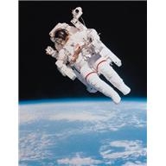](javascript:void(0))

**~Youth Event~**

**A Visit from an Astronaut**

**with guest speaker**

**Duane G. “Digger” Carey**

**Retired USAF Lieutenant Colonel and Former NASA Astronaut**

**October 17, 11:30-3:00pm**

**The Wellstone Center - 179 Robie Street E., St. Paul**

**Parking is available in the ramp attached to the building**

**Lunch will be provided!**

**Sponsored by**

